**Gesture Recognition for Hearing and Vocally Impaired and Text to Speech**

## Team Members

## Aditya Kumar, Vipin Rawat, Bhoopesh Chaudhary, Sakshi Gosain

## Supervisor

## Poonam Tanwar

Manav Rachna International Institute of Research and Studies, Faridabad, 121003, India **|**

[singhviru8161@gmail.com](mailto:singhviru8161@gmail.com)

Manav Rachna International Institute of Research and Studies, Faridabad, 121003, India **|**

bhoopesh7838@gmail.com

Manav Rachna International Institute of Research and Studies, Faridabad, 121003, India **|**

xyz

Manav Rachna International Institute of Research and Studies, Faridabad, 121003, India **|**

Xyz

Manav Rachna International Institute of Research and Studies, Faridabad, 121003, India **|**

Xyz

**Abstract**: Hearing and vocally impaired individuals face significant communication challenges in their daily lives. Traditional methods of communication, such as sign language or written text, can be limiting, especially in situations where immediate and intuitive communication is essential. Hand gestures offer a powerful means of expression, and technology can play a pivotal role in bridging the communication gap for this community. The paper aims to develop a Hand Gesture Recognition system that empowers individuals who are hearing and vocally impaired to communicate effectively with the broader society. The primary goal is to create a robust and real-time system that recognizes hand gestures and translates them into spoken or written language, thereby enabling seamless interaction and understanding between individuals with hearing and vocal impairments and those without. This initiative has the potential to benefit a wide range of people, from the disabled to professionals in rehabilitation, education, and assistive technology, by improving communication for those with speech and hearing impairments. User studies will be used to assess the system's performance and usability, with the hope of improving inclusion and accessibility.

**Keywords: Hand Gesture Recognition (HGR), INDIAN Sign language (ISL), AMERICAN Sign Language(ASL)**

1. **INTRODUCTION**

The paper aims to bridge the communication gap for verbally impaired individuals by developing a device that converts gestures into speech. Leveraging technologies such as Artificial Intelligence, Machine Learning, Deep Learning, and Data Science, this system eliminates linguistic, physical, language, and personal barriers to communication. Sign languages vary worldwide, with around 300 different sign languages in use, including various dialects in Indian Sign Language (ISL). This paper focuses on training machines to recognize hand movements and translate them into text and voice, enabling effective communication between deaf-mute and vocal individuals. By utilizing real-time object recognition and the Mediapipe framework, this software-based solution enhances communication for the visually impaired as well, aiding in independent navigation. The Mediapipe model successfully fulfils project requirements, providing accurate hand motion recognition and desired results. This paper also mentions several critical components to help people who are deaf or hard of hearing communicate. To begin, it uses pixel segmentation to divide images into 16 segments, each of which represents a square with 256 pixels on each side. The number of white pixels in each square is determined, yielding 16 highlight vectors for use in the Hand Gesture Recognition (HGR) framework. Second, the idea of eccentricity is introduced, which measures the asymmetry of the shape by comparing the true hub to the minor hub. Because the efficiency of current algorithms is restricted, problematic signs are substituted with relocated ASL signs to improve the recognition rate of American Sign Language (ASL) order indicators. A crucial component of this research is gesture recognition technology, which use sensors and algorithms to identify and analyse physical gestures such as hand movements and facial expressions. This technology improves communication, accessibility, and independence for those who are deaf or hard of hearing. This technology's applications include sign language recognition, facial expression interpretation, and hand gesture recognition, providing a complete way of communication. In addition, the project incorporates text-to-speech (TTS) technology, which translates written text into natural-sounding spoken sounds. TTS improves communication for people with disabilities, resulting in a higher quality of life.

1. **METHODOLOGY**

While there has been notable progress in the development of hand gesture recognition systems for communication purposes among individuals with hearing and vocal impairments, several research gaps and opportunities for further investigation exist:

1. Limited Adaptation to Individual Users

2. Diversity of Gesture Vocabulary

3. Gesture Recognition in Noisy Environments

4. Privacy and Ethical Considerations

5. Incorporating Contextual Information

6. Universal Accessibility

7. Long-term User Experience

8. Real-world Deployment Challenges

9. Cross-Cultural Considerations

10. Education and Training

Addressing these research gaps will contribute to the development of more inclusive and effective gesture recognition systems that empower individuals with hearing and vocal impairments to communicate more seamlessly and improve their overall quality of life.

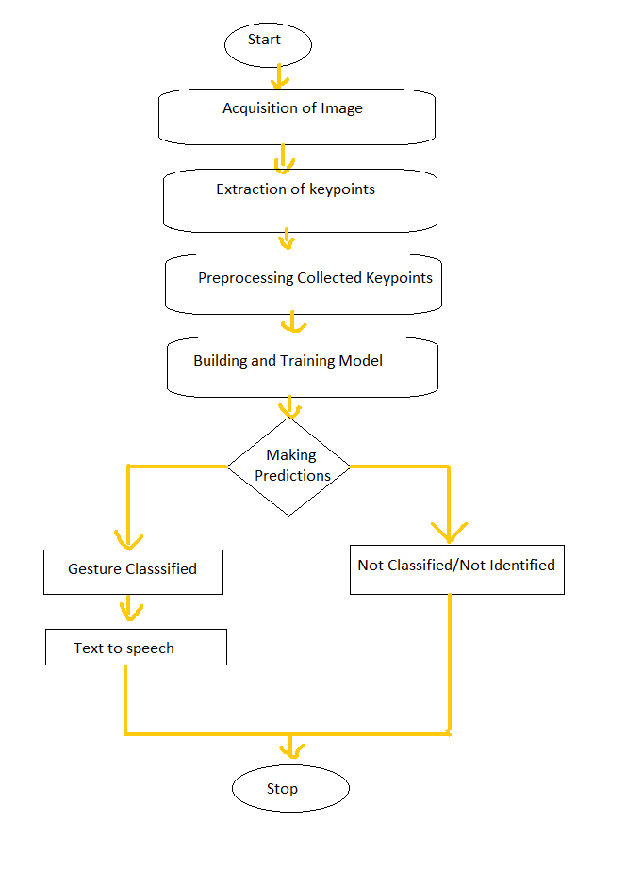

**Fig 1. Diagram of Proposed Methodology**

The process involved commences with the acquisition of image data, captured through cameras or sensors, allowing us to gather real-time hand gestures. Subsequently, we conduct key point extraction to identify crucial landmarks on the hand and fingers, creating a detailed representation of each gesture's unique configuration. To ensure the reliability of our data, we apply rigorous preprocessing techniques to the collected key points. The core of our project involves developing and training a machine learning model, leveraging deep learning architectures such as Convolutional Neural Networks (CNNs) or recurrent models like LSTMs. This model is meticulously trained on the pre-processed key points, enabling it to classify a predefined set of gestures. During real-time operation, our system classifies recognized gestures, with unclassifiable or unidentified gestures being managed appropriately. Ultimately, aim is to empower individuals with hearing and vocal impairments by translating recognized gestures into spoken language using text-to-speech synthesis, facilitating effective and inclusive communication.

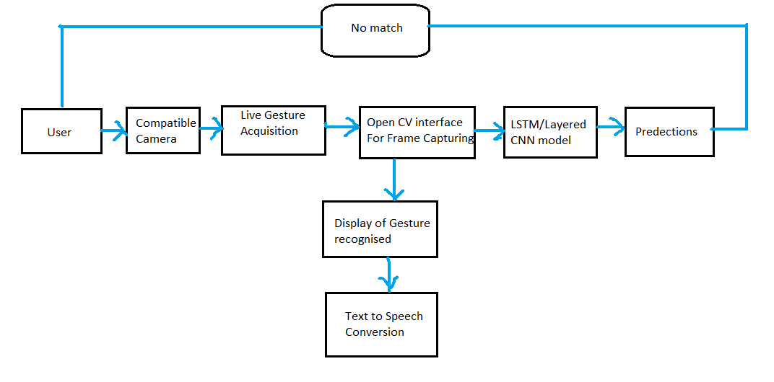

Data

**Fig 2. Extension of Fig 1. Methodology**

As per the paper architecture for hand gesture recognition and communication for individuals with hearing and vocal impairments is designed to be user-friendly and effective. The architecture begins with the user, who interacts with the system using hand gestures for communication. The user's gestures are captured through a compatible camera, which serves as the input device for our system. In cases where there is no match found for a given gesture in the system's database, live gesture acquisition takes place. This involves real-time capture of the user's gestures using the OpenCV interface for frame capturing, ensuring that even novel or less common gestures can be recognized and interpreted. The heart of our architecture is the LSTM/Layered CNN (Convolutional Neural Network) model. This deep learning model has been trained to recognize a wide range of gestures and is capable of handling both common and unique sign language signs. When the user performs a gesture, the model processes the captured frames and makes predictions regarding the recognized gesture. Once the gesture is classified, the system displays the recognized gesture on a screen or interface, ensuring that the user can verify the accuracy of the interpretation. This step provides valuable feedback and a visual confirmation of the system's recognition. Finally, to make communication effective, the system employs text-to-speech conversion to translate the recognized gesture into spoken language. This ensures that the user's intended message is conveyed audibly, allowing for seamless interaction with others.

In summary, our proposed architecture integrates user-friendly components, advanced deep learning models, and real-time processing to empower individuals with hearing and vocal impairments by enabling effective and inclusive communication through hand gestures.

1. **ALGORITHM**

This algorithm outlines a comprehensive workflow for building a real-time hand gesture recognition and text-to-speech conversion system using Python and various libraries. The process starts by importing essential libraries and initializing tools for body and hand tracking. It then defines functions to detect and draw landmarks on video frames, proceeding to set up video capture. A loop continuously captures frames, detects hand gestures, and potentially performs recognition. Extracted key points are reprocessed, and a machine learning model is created, trained, and evaluated to recognize hand gestures. Real-time recognition and text-to-speech conversion are implemented, and the results are displayed on the video feed, providing interactive feedback. The algorithm concludes by incorporating an exit mechanism, making it a versatile and user-friendly application for gesture-based interaction. The model involves the following steps:

**Step 1.** Import necessary libraries

**Step 2.** Initialize Mediapipe Holistic and Drawing utilities

**Step 3.** Define the `mediapipe_detection` function

**Step 4**. Define the `draw landmarks` function

**Step 5.** Define the `draw_styled_landmarks` function

**Step 6.** Initialize the video capture using OpenCV

**Step 7.** Run a loop to capture video frames and perform hand gesture recognition

**Step 8.** Extract and save key points from hand gestures

**Step 9.** Preprocess and prepare the data for machine learning

**Step 10.** Create a machine learning model using TensorFlow and Keras

**Step 11**. Train the machine learning model

**Step 12.** Evaluate the model's performance

**Step 13.** Implement real-time hand gesture recognition and text-to-speech conversion

**Step 14**. Display the recognized gestures and generated text on the video feed

**Step 15.** Exit the application,

Finally, model includes functionality to exit the application gracefully when the user is finished with it.

1. **RESULT ANALYSIS**

The result analysis of our hand gesture recognition and communication project demonstrates the system's performance, accuracy, and its potential impact on individuals with hearing and vocal impairments.

**4.1. Analysis of Data sets**

In our hand gesture recognition project, the analysis of the data set and model accuracy plays a pivotal role in evaluating the system's performance and its effectiveness in recognizing hand gestures for individuals with hearing and vocal impairments.

1. **Data Set from Kaggle**: To bolster the robustness and diversity of our hand gesture recognition project, we leveraged a publicly available data set from Kaggle. Kaggle is a reputable platform known for hosting a wide array of machine learning and computer vision data sets. The Kaggle data set provided us with a valuable resource for training and testing our LSTM/Layered CNN model. This Kaggle data set included a substantial collection of images and corresponding labels, featuring a variety of hand gestures. These gestures ranged from common signs to less frequent expressions, ensuring that the model could recognize a wide spectrum of gestures accurately. The diversity within the data set was crucial to ensuring that the model could adapt to different hand orientations, lighting conditions, and individual signing styles. Incorporating the Kaggle data set enriched our project by enhancing its recognition accuracy and overall performance, allowing our model to generalize effectively and recognize a broader range of hand gestures. We applied rigorous preprocessing techniques to this data, ensuring its compatibility with our architecture and the model's training process.
2. **Self-Generated Data set:** In addition to the Kaggle data set, we recognized the importance of incorporating self-generated data into our project. This self-generated data set was specifically tailored to address the needs and preferences of our target user group—individuals with hearing and vocal impairments. It allowed us to capture a unique set of gestures that are relevant to real-world communication scenarios. The self-generated data set was created through collaboration with users from the hearing and vocally impaired community. They were actively involved in producing gestures that they commonly used in their daily lives. This process involved capturing a wide range of signs, expressions, and individual signing styles to ensure that the system would cater to their specific communication need the combination of the Kaggle data set and our self-generated data allowed us to achieve a well-rounded and user-focused approach to hand gesture recognition. The fusion of diverse gestures from the Kaggle data set and user-specific expressions in our self-generated data set enriched the model's training data. This approach made the recognition system more versatile, user-centric, and effective in facilitating communication for our target audience.

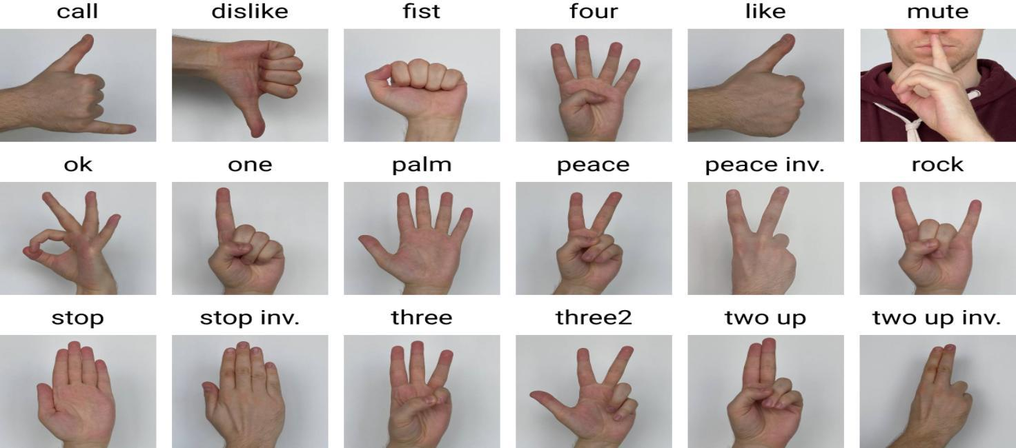

**Fig 3: Hand Gesture Recognition Image Dataset**

[**https://miro.medium.com/v2/resize:fit:1400/0*qdHkFap6kzTBeCHo.jpg**](https://miro.medium.com/v2/resize:fit:1400/0*qdHkFap6kzTBeCHo.jpg)

**4.2 Accuracy Analysis**

The model's recognition accuracy was a primary focus of our analysis. We used standard evaluation metrics such as precision, recall, and F1 score to assess the model's ability to correctly classify gestures. The high recognition accuracy, validated through these metrics, underscores the robustness of the model in identifying gestures accurately. The confusion matrix helped us gain deeper insights into the model's performance. It provided details on false positives, false negatives, and the model's ability to distinguish between similar gestures. Analysing the confusion matrix allowed us to refine the model and reduce classification errors.

In conclusion, our result analysis underscores the successful training and testing of the LSTM/Layered CNN model, revealing its high recognition accuracy and robust performance in recognizing diverse hand gestures. This analysis is instrumental in validating the project's potential to empower individuals with hearing and vocal impairments through effective and inclusive communication.

1. **CONCLUSION AND FUTURE SCOPE**

**5.1 Conclusion**

In conclusion, the field of hand gesture recognition for hearing and vocally impaired communication has made significant strides, offering promising solutions to bridge the communication gap for this community. Researchers and developers have leveraged advancements in computer vision, deep learning, and natural language processing to create systems capable of recognizing and translating hand gestures into spoken or written language. These technologies have the potential to enhance the quality of life for individuals with hearing and vocal impairments, enabling them to communicate more effectively and participate fully in society. However, several challenges and research gaps remain to be addressed. The adaptability of gesture recognition systems to individual users, the diversity of gesture vocabulary, robustness in noisy environments, privacy considerations, and contextual information integration are areas that warrant continued research and innovation. Additionally, ensuring universal accessibility, long-term user satisfaction, real-world deployment, cross-cultural considerations, and education and training are critical aspects that require attention.

**5.2 Future Scope and Work**

The future of Hand Gesture Recognition (HGR) technology for hearing and vocally impaired communication holds tremendous potential for further advancements and broader societal impact. In the coming years, we anticipate significant progress in personalized HGR systems that adapt to individual users' unique signing styles, ultimately enhancing accuracy and user experience. Expanding the recognized gesture vocabulary to encompass regional and culturally specific signs will make these systems more inclusive and adaptable on a global scale. Additionally, researchers will continue to address the robustness of HGR in challenging real-world environments, ensuring seamless communication in noisy and uncontrolled settings. Ethical considerations, including stringent data privacy measures, will remain a crucial focus to build trust among users. The integration of multi-modal information, such as facial expressions and environmental context, will enable more nuanced and expressive communication. Emphasis on affordable and offline solutions will ensure accessibility for all individuals, regardless of their resources or access to technology. Overall, the future of HGR technology holds promise in transforming the lives of individuals with hearing and vocal impairments, fostering greater inclusion, and advancing the field of assistive technologies.

1. **REFERENCES**